The study on the Features of Avant-garde exposed in the New Design Movement as a View of Expressionism
Focusing on the Interrelation between Expressionism and Post-modernism

NAME(author-1)

Kookmin University

NAME (author-2)

Kookmin University

Abstract

The purpose of this study is to understand and interpret interrelation between contemporary art and design, and analyze designers how to universalize personal conception and attitude in furniture design. The process of this study is illustrated as follows: At first, this study validates how to be defined interrelation between contemporary art and design, in terms of confronted phenomenon between plastic aspect and expressive aspect in contemporary art, that is, modernism as plastic tendency and post-modernism as expressive tendency. Secondly, under the assumption of plastic flowing to modernism and expressive flowing to post modernism, this study is considered that the aspect of Avant-garde philosophy of expressionism in modern art has been reflected in New Design. Finally, it is considered that these definite examples with four aspects, Neo-Baroque, Art Nouveau, Ready-made and Surrealism, which are revealed in the Avant-garde expressive feature in New Design, as a phase of post-modernism are examined.

Keywords: New Design, Post-modernism, Expressionism, Avant-garde

1. INTODUCTION

1.1 Purpose of the study
Art is a beautification process or creative performance by which the social environment is subjected to an artistic value. Art reflects the spirit and the social consciousness of the ages, providing objective sociality as well as esthetic pleasure. This study aims to review how the features of Avant-garde are reflected in the New Design movement, an experimental movement of the new aesthetics of the post modernism and shock treatment, assuming that Postmodernism evolved from the Expressionism movement of the paintings. It is a well-known fact that the New Design movement of the 1980s raised very serious questions about the modernistic value: a value that represents the International style and Good Design. This movement expressed a fundamental doubt about Bauhaus traditional rationalism and bitterly criticized the mass consumption society while at the same time opposing the commercial standardization of pictures. The tendency of artists of this movement carried on extending the consequence of their works, ridiculing their mainstream value.
This paper aims to illuminate their world by focusing on a few expression patterns manifested in their works. It is obvious that Expressionism is a varied field and a complicated one. This paper will especially focus on the expressional aspects of the movement’s works. The analysis of the correlation between Expressionism and Design will prove that the latter reflects the current thoughts and ideas immanent in art and in addition gives creative expression to art. Furthermore, this paper will prove that it is possible to link the tendency of expressionist art to the principle or idea of design.

1.2. The method and range of the studya
The artistic will started from the esthetical reformation in the modern ages and linked with esthetical plastic, spacail plastic and finished with architectural plastic, as the ultimate objective. This resulted in the transformation of Design. This study will try to analyze how designers generalized designs with their ideas and attitudes through a variety of thoughts using art.
First, It is important to grasp the two streams of modern art, the confrontation concepts of Determined Relations and Internal Necessity as advocated by Herbert Read. There after a look should be taken at how these streams were defined from the view of design development in both Plasticism and Expressionism. Second, under the assumption of plastic flowing to modernism and expressive flowing to Post-modernism, the aspect of the Avant-garde philosophy of expressionism in modern art being reflected in Post-modernism will be considered. Third, we will consider these definite examples with four aspects, Neo-Baroque, Art-Nouveau, Ready-Made and Surrealism, which are revealed in the Avant-garde expressive technique of New Design, as a phase of post modernism. The objective of this study is to illustrate and enlarge the creative possibilities of Designing. The redefinition of the concept of Design in relationship to art is another goal of the study.

2. POST-MODERNISM AS THE STREAM OF EXPRESSIONISM

2.1. The stream of modern art and its relation to designing waves
There are two confrontational aspects of design, such as, emotions and rationality, ideality and reality, value and taste, personality and popularity, honor and dishonor. Since the onset of the modern age in the western world, the local traditions have crumbled and the international tide has risen to the forefront. There are two main trends emerging from the 20th century; abstract art and expressive art. Expressive art concentrates on the artist’s emotional attitude about himself or his world, while abstract art emphasizes the formal structure of artwork. Both objective external worlds and subjective internal worlds coexist inside of artist's minds. Either one or the other of the worlds are exaggerated or contracted according to the time period. The same viewpoint can be taken regarding Plasticism and Expressionism as modern art. The concepts of Plasticism and Expressionism are always confronted with each other, such as, intuitive or rational, artistic or scientific, mental or material, individualism or generalism.
Herbert Read explained these two confrontations as "an Art of Determined Relations" as featured in the works of artists such as Piet Mondrian, Ben Nicholson, and "an Art of Internal Necessity" as seen in De kooning's works. "An Art of Determined Relations" means the stream of pure plasticism, which contains geometric abstracts and formations. "an Art of Internal Necessity" points out the stream of expressionism. These can be separated into the publicity of art and the absoluteness of art. It is possible to categorize these arts as follows:
(1) Plastically, an Art of Determined Relations, the pursuit of the plastically order of the external world, the basic rule of plastically components transcends humans, formation and plasticism.
(2) Expressionism, an Art of Internal Necessity, explores the eye of human mysteries and the expression of the artist's soul, expressions and fantasy.
Modern architecture bores features of concepts of functionalism and expressionism. As one of the most prominent architects, S. Giedion explains in his book,「Space, Time and Architecture」, these two concepts divide historical ideas. One is the structural fact that appears in history repeatedly and establishes a new tradition. The other concept is the transitional fact that might be fashionable for a short time but is soon absorbed into a new tradition. S. Giedion described the structural fact as existing at a particular time and ignoring everything else.
He stated that only the structural fact expresses the spirit of the times. The structural fact was formed by modernism as the stream of design. The transitional fact faded but rose once again through the contemporary architecture of Post-modernism.

2.2. Expressionism and Post-modernism
This study postulates the relation of pictures and design as "an Art of Determined Relations"; the stream of the pure Plasticism of geometric abstracts and Structuralism and as "an Art of Internal Necessity"; the stream of Expressionism. "An Art of Determined Relations" appears in Modernism and "an Art of Internal Necessity" appears in Post-modernism. In the first half of the 20th century Modern Design was related to plasticism and there are some other expressive concepts or techniques, which in turn influenced modern and present design.
It is however true that expressionism did not become the main stream of art because of Neo-plasticism’s influence, which is based on geometric abstract. Expressionism has been experimented by more artists, (such as, Salvador Dali and Marcel Duchamp) than people involved in the architectural field.
In 1912, Adolf Behne defined expressionism in the magazine「Pan」, pointing out that his understanding was somewhat similar to Bruno Taut’s architectural style and the works of expressive artists, such as, Die Bruckes or Oskar Kokoschkas works. His main argument is that artwork is the production and it is given free form by the artist’s ability. Read stated his opinion in the following manner: expression means that Internal emotions are expressed in external worlds. Therefore, when Expressionism reveals internal emotions towards the outside world, artists are not respecting and keeping the habits and traditions and are limiting their expressions while respecting their own emotions and ignoring the external worlds. That is to say, that Expressionism does not describe the abstract idea due to the objective truth of the nature, but strongly expresses the artists subjective emotion. It can be proven that expressionist artists esthetical features are against the traditional structure and that these artists pursue the free formations of objectives.
The first half of the 20th century's German expressionist movement with the background of theoretical; critical, historical books published in the second half of the 19th century will now be analyzed. The Neo-Kantist, Conrad Fiedler stated that the formation of art works originated from an idea. He did not grant any impulse or mysterious meaning to Internal Necessity, instead he said that artwork is the product of Internal Necessity and he agreed with the issues of personal creationism. At the same time, Conrad tried to research the possibilities of the personal creationism as objective art studies. The art historian, Wilhelm Worringer became a leading supporter of expressionism by publishing his book,「Abstraktion und Einfuhlung(1908)」.
Expressionists drastically transform the formation of objects in order to express their emotions plastically. These non-ideal and subjective features of Expressionism were reevaluated given the similarity to Art Nouveau and Surrealism. The phenomenon of return to the oppression as advocated by Sigmund Freud argued that surrounding objects; which were restrained or ignored under the modernist period of patriarchal systems; arose in the works of Postmodernist, which admitted their meanings and values. Therefore, it can be debated that Postmodernism arises from surrounding objects. For example, counter-culture against the established culture, public-culture against the old-fashioned, elite and high-class culture. Ultimately, this phenomenon originated from the withdrawal from general culture and started to appear repeatedly through the works of postmodernists. It can be argued that postmodernism is the logical extension and succession of modernism. At the same time, it is arguable that postmodernism is a critical reaction to and even the extinction of modernism. This paper postulates that Postmodernism wants to suggest a new alternative way of getting over the limits and contradictions of modernism.

3. THE AVANT-GARDE FEATURES OF POST-MODERNISM

The symbolism of art contains lots of meanings, such as, social messages, unconscious states of people's minds, as well as the transcendental nature of religion. Postmodernism has an undetacable relationship with Avant Gardism. Both of these traditions and theories started in this century, therefore, both of these basically reflect the thoughts of this century even though they have some important differences.
As Peter Buerger in his book,「Theorie der Avant-garde (1980)」, pointed out, Avant Gardism criticized the features of elitism and seriousness, which high-class art was aimed at and they tried to bring the art that had been excluded back into the real life. Avant-garde regarded. Unification of art and life Hegel-Marxian terms as the most important goal of estheticism. As Avant-garde basically means destruction of the existing system and the establishment of a new society system, Avant Gardism performed these roles in society as an artistic guerrilla.
Avant Gardism is based on the social phenomenon, which depends on Anti-social features that are expressed and supported by cultural and artistic proclamations. Avant-garde deformation refuses the established order and chooses a given style to recreate order in society. Avant Gardism essentially has the same root as postmodernism. Some theorists call postmodernism Neo Avant-garde for the same reasons.
Postmodernism is described as a reactionary power against Modernism, which expresses the present variety of the consumer's culture. Postmodernism criticized Modernism by pointing out the problems associated with the latter. Since the middle of the 1970s, the questioning of Design Language Necessity by designers, which was limited artificially, led the designing expressions to be liberated from the influences of basic reason. Art Nouveau, Dadaism and Surrealism gave important spiritual and technical motivation to the post modernistic designs. Most techniques of post modernistic designs used in the present time are using the same experimental styles employed by Avant-gardism at the beginning of the 20th century. The Collage and Ready-Made techniques expressed in Dadaism and Surrealism assured the need for creative thinking in the formation of art.
Avant Gardism is a phenomenon, which does not use any examples from the past traditions of culture and art. Avant Gardism leads the absolute, unique and eternal poetics to be cautious and gives the value to the experimental movement of the eternal track of human time. The experimental aspect of avant-garde art is manifested not only in depth, within the limits of a given art form, but also in breadth, in the attempts to enlarge the frontiers of that form or to invade other territories, to the advantage of one or both of the arts.
While Avant Gardism is mentioned as an art creation dimension, the will of Avant Gardism belongs to the unconscious, irrational and automatically sphere not the conscious, rational and self control one. This thought arose from the will of Avant Gardism, which regards human thought as the only machinery combination of idea, therefore Avant Gardism belongs to the irrational. The Automatism, the stream of consciousness and the fictitious installation of Surrealism prove that Avant Gardism does not have any artistic will.
For that reason, Avant Gardism is attracted to new or strange tendencies like Romanticism. Avant Gardism took over the traditions of Romanticism. Therefore, Avant Gardism can be called Neo-Romanticism.
Poggioli, in his book「The Theory of the Avant Garde」, explained that Avant Garde was a general phenomenon, which was able to appear at any historical age rather than only during specific historical periods. Avant Gardism is the creation of historical periods, that is to say, it arises from the will of a new style to establish a new order in society, refuting the past order of society. New orders and new styles have important meanings.
According to Poggioli, the idea and spirit of Avant Gardism are associated with Postmodernism. Regarded as the logical and cultural point that is coping with the present situation, Avant Gardism is the essential law of culture and art in our time. Avant Gardism started during the period of Postmodernism and is a combination of the present cultural movement and the spirit of the contemporary.

4. AVANT-GARDE'S EXPRESSIONISTIC PROPERTIES IN NEW DESIGN

New Design was expanded as a completely independent style under the special rubric in Spain, German, France and England but it was one of the Avant-garde movements of postmodernism.
Their thinking was independent of industry and the partiality of functionalism, reflecting instead a metropolitan sense of life, the changes in fashions, and the influences of subcultures and daily life in their method of using the media as a platform for their work. The shock therapy of the new aesthetic and the experience gained from their experimental work provided new impulses for furniture and industrial design.
Like the punk movement, and most antiestablishment waves, the protest gestures of the New Design were absorbed by the consumer goods industry and turned into fashion. New Design had been responsible for important lines of thought in education and work in industrial design in the 1990s.
These features of the Avant -garde movement, which are revealed in New Design will now be considered and some examples of Avant Gardic techniques present in Expressionism will be introduced.

4.1. Neo-Baroque
Post-modernism was born as the reaction of the present cultural varieties to the mechanical ideas of Modernism, which regards the nature of objects as being important. Therefore, there are big differences between post-modernism and modernism. As the leader of the genealogy of post-modernism, Baroque should be singled out as an example of Irrationalism and Rationalism represented in the Renaissance and the Enlightenment. Postmodern society contains indeterminism, since an event is determined the truth of the event will be understood by the society, but anonymous people will interfere in the course of the solution. (Anonymous people can be separated as the consumers, the readers-receiver who are answering as the writer-sender.)
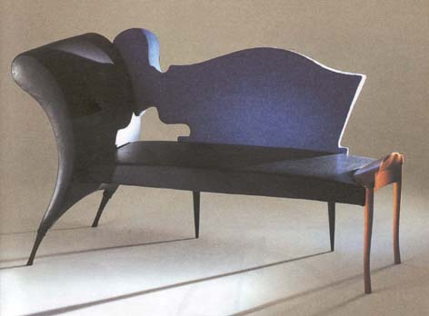
Figure3. Chaise lounge,
Prosim Sni,
by Borek Sipek
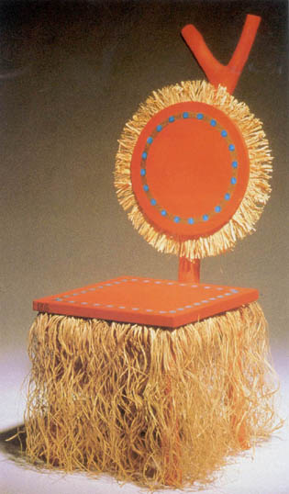

Figure1.Prince Imperial Chair, by Garouste and Bonetti
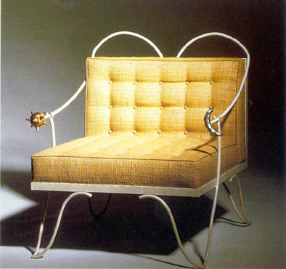

Figure2. Jour et Nuit Armchair, by Garouste and Bonetti
Art can only gain meaning at the consuming step, not at the producing step. The writer has the image of creating a world that changes according to the intention of the receivers, not an absolute and unique image. Hence, art is the creation of new rationality, called "the artificial rationality" in the Baroque. Art is just not representing a given nature or an idea any more.
The historical period of the Baroque originated the possibility of artwork creating images. Post-modernism is based on the public culture and history and follows design as a symbol and ideogram, which is able to interpret the art. Post-modernism is not the extreme abstract, but let people feel the richness involved the cultural tradition. Post-modernism is the growth of expressionism.

Baroque is about pearls which are not completely round. Baroque means the style of unbalance, funny and irregular nuances. Sometimes, Baroque means ridiculousness with refinement or abuse.
Heinri Wolfflin, when comparing the Renaissance and the Baroque in「Principles of Art History」 stated that both styles have unique features. To him, the Baroque was an answer to the Renaissance. He grasped that the Baroque expressed the special spirit and idea of an era, which conflicted with the ideas of the Renaissance.
Baroque is a reaction against the harmonial idea; the balance of beauty and logic of the Renaissance. It is the spirit of an era, which expresses in historical terms that the power of passion or the fantasy wins over the rules of balance. Baroque is an art that successfully pushes back the limits of balance, harmony and safety, which are crossed, broken and cut. Baroque has a style that translates the human soul into a form and that expresses the passion or the fantasy and which cannot be expressed by the rules or the measures of society.
Elizabeth Garouste and Mattia Bonetti have been pioneers in breaking the black-white conventions and the linear structure proposed by the modern movement, and in criticising the limitations of high-tech. They offer the challenge of a fresh new language, termed Neo-baroque, with its in primitivism, the oneiric worlds of fantasy and in the tradition of the french decorative arts. (Figure 1, 2)
Borek Sipek, the Czech star designer, is a chief representative of the neo-Baroque direction in New Design. Neo-Baroque furniture quotes the involuted asymmetrical forms of the Baroque, often using luxuriously campy materials. (Figure 3)

4.2. Art Nouveau

Art Nouveau was the direct ancestor of expressionism more than the origin of an inspiration. Many artists who are proponents of expressionism, such as, Bernhard Hoetger, a sculptor started his works from the Art Nouveau movement, and the radical Art-nouveau architect, Antonio Gaudi as an example can be separated as an expressionist. Expressionism is the developed formation of Art Nouveau in many aspects. That is to say that Art Nouveau was the attempt at exploring new styles and was characterized with the curved, sculptured plastic elements from animals, plants and human bodies.
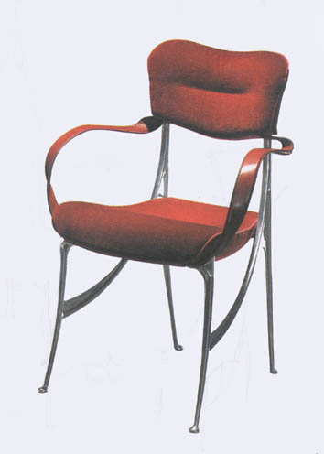

Figure 4. Chair by Oscar Tusquets, Overtones from art nouveau are
unmistakable
Art-Nouveau gave the solutions to the artists and architects who were searching for new thoughts and wanted to express the ideas of the present through these new thoughts, but who were confronted with how to express these ideas. Art Nouveau is not just a style of art, but a movement containing diversity. Art Nouveau is an expression of Avant-garde which involved symbolism different from modernism.
The Spanish architect and designer Oscar Tusquets Blancas designs are featured in the Art-Nouveau images of his works.
Tusquets regarded Euclid geometry as the existence limiting artistic expression and revived the Art-Nouveau image used in the formations and patterns of symbolic aesthetics. The Art-Nouveau visual image has been reflected in the furniture industry, illustrating Tusquets genius. Tusquets was one of New Design frontiersmen of Spain. By the reviving Art Nouveau images, he pursued the fantasy of vital forms and richness of plastics, liberating them from the rules of design. (Figure 4)

4.3. Ready-Made

Avant-garde is the idea that arts and artists discover or create a new history in the society. It studies the possibilities of the new style and new language of art through the aesthetical destruction and reformation. Dada was not a school of artists, but an alarm signal against declining values, routine and speculation, a desperate appeal, on behalf of all forms of art, for a creative basis on which to built a new and universal consciousness of art.
Artworks such as the using of bicycles wheels or toilets are very different from the artistic taste of the Bourgeois. However, Ready-Made is more than just the production of the anti-artistic movement. Ready-Made can be regarded as a serious challenge against the values of the Bourgeois societal system.
Duchamp completely refuted the traditional ideas of art, like modernism, through his work. He questioned the features and roles of art and the essence of artistic tastes. Traditionally, artworks are beautiful aesthetical objects with harmony and balance, and are different from common objects, which are used in life. Duchamp refused this kind of artistic idea and broke down the wall existing between the aesthetical artworks and common objects. Moreover, he ignored the traditional idea that an artwork is grasped as the artist’s creative behavior.
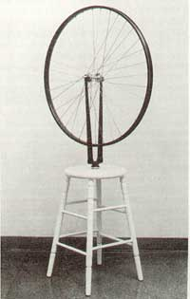

Figure 5. Bicycle Wheel, by Marcel Duchamp
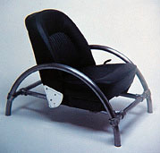

Figure 7. Rover Chair,
by Ron Arad
Ron Arad, the Israeli sculptor, architect and designer, whose sense of the formation of sculpture was influenced by Henri Matisse and Class Oldenburg, developed voluptuous and sensual designs. One of his first designs, the Rover Chair, from the seat of a Land Rover, was made in the following fashion: he covered the recreated Rover car seat with a tubular frame. This design became the origin of Ready-Made in England. (Figure 7)
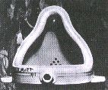

Figure 6. Fountain,
by Marcel Duchamp
A point must be made about Automatism and Occidentalism as Ready-Made methods. These methods use objects, which have already been mass-produced or copied in order to use them in their artworks. Therefore, artists can reduce their creation time and produce their artwork with the association of ideas. These methods are related to a certain place and time. Plainly speaking, it is to switch the object, which should be in a certain time and place, into a different time and place. Hence, the objects are aimed at illustrating artistic nihilism or sarcasm and intended to show the associational value of the objects themselves, not the aesthetical value. The intention behind the design of these objects was to shock and to question traditional design terms.

4.4. Surrealism
The genealogy of Surrealism started earlier than Dadaism. Surrealism emphasizes destruction, radicalism, artistic chaos and disorder. Surrealism was rooted in Hegel, Romanticism or symbolism at this point. This is the reason Andre Breton described Surrealism as "A tale of Romanticism".
In 1924, Breton in his book「Les Manifestes du Surrealism」, mentioned that Surrealism is a movement that combines the conscious sphere with the unconscious sphere completely and equates the world of dreams and fantasy with the real world. Breton thought of the unconscious world as the origin of imagination, a view that was shared by Freud himself. According to Breton the greatness of an artist depends on how close he (or she) nears the unconscious world rather than through the normal sphere of rationality.
Surrealism brings up the duplicity of an object and lets the object liberate itself from its simple original use. Breton's statement, "All objects are symbols in themselves", illustrates this point. Oscar Tusquets designs can also be understood as an example of Surrealism.
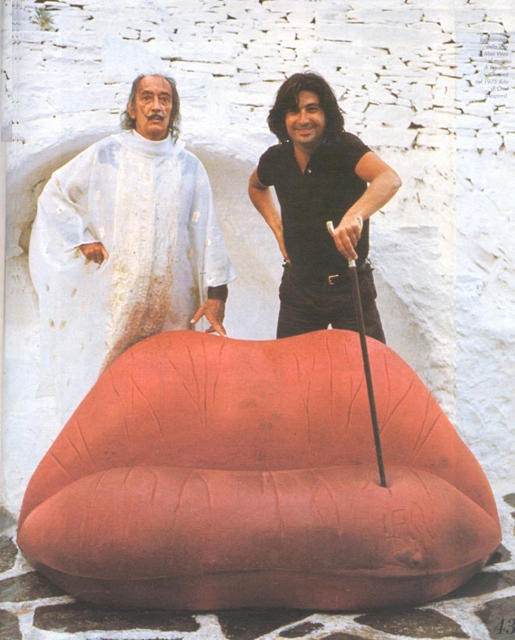

Figure 9. Oscar Tusquets

with Salvador Dali
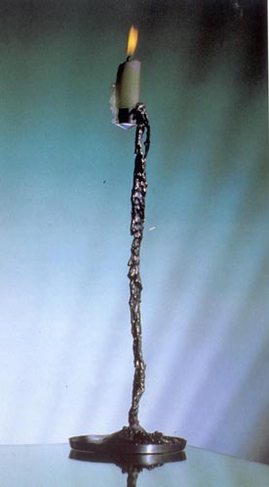

Figure 8. Salvador Candelabrum,
by Oscar Toques
His design is always accompanied by the search for beauty, and to attain it he enters a surrealist dimension, which makes each form startling and unexpected.
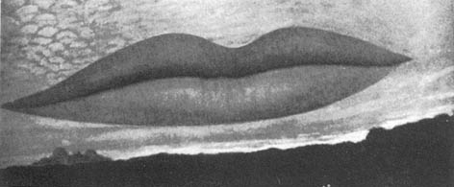
The name of the Candelabrum reveals that it is Oscar Tusquets' homage to the artist, Salvador Dali. Indebted to the formal and critical universe of Dali, to his thought and behavior, Tusquets was inspired by Dali's personality in the creation of this unique Candelabrum. (Figure 8)
Figure 10. Obseratory Time,
-the lovers, by Man Ray

This is an artistic design whose form makes it seem to aspire to encounter superior dimensions and ratify the immortality of the surrealist creator. A relationship can be seen between sofa by Tusquets (Figure 9) and Man Ray's observatory time- the lovers (Figure 10). Tusquets reflected the Freudian association with the libido- a kind of frivolous wonder-, which Surrealists highly praise in this painting. The poetic attraction and mysterious feeling of the artwork is the creation of ones internal desires and sudden juxtaposition from the artist’s unconscious memory. As revealed from Tusquets series, many techniques have been tried in New Design, which had been previously experimented with in Surrealism. Designing techniques from Surrealism contain material juxtaposition, visual pun, poetic analogy, deformation of scales as well as the expression of unconscious desires.

5. CONCLUSION

According to the proposition, "The style is born of combining form and content" Modernism and Post-modernism, which are separated by their styles; should represent the styles that are reflected in the spirit of a particular era. This study focused on how the expressive features of the contemporary art are applied in Post-modernism. The point is that plastic principle of contemporary design started from paintings and was influenced by design. Many of the postmodern designs are influenced by Avant-garde techniques that were experimented with at the beginning of the 20th Century. Varied techniques such as, Collage and Unfamiliarity, were intended as important designing motivations and these techniques are used in several designing tendencies. Post-modernism is the reincarnation of Modernism. Given that Modernism experiments progressed on an equal level with the Avant-garde ones, it can easily be argued that most of postmodern designs are borrowed from Avant-garde experiments. This study outlined the course from the stream of expressionism to that of Post-modernism, and considered what are the features of Avant-garde, which is a tendency of the postmodern designs, that influenced the New Design.
Against the modernistic art philosophy of good design and good taste, more specifically mass production and consumption, which are in essence the motto of the industrialized world, the pretest gestures of the New Design has created a new horizon for design. These new techniques try to give new meanings to consumer good industry. Design is situated in the style and ideas of a specific period at the bottom of a society as a form of culture. Furthermore, design is the reflection of people's thoughts about the cultural consciousness of an era. As Walter Benjamin started toward to literature, Design should be the work which suggest the era in our minds at the time Design were born, not just suggest that artworks are being related with the period.
This study ascertained that Design is a societal phenomenon, which can be created by a society's values through a variety of ideas and from the application of different art fields. Design is a moral, intellectual phenomenon of a given period, which has a deep relationship with culture and societal change, not just putting value on external forms and ceasing only at the definition of aesthetics.

REFERENCES

1. Read, Herbert, A Concise History of Modern Painting, Thames and Hudson, 1974
2. Hauffe, Thomas, Design: A Concise History, London, Lawrence King, 1998
3. Poggioli, Renato, The Theory of the Avant-garde, trans. Fitzgerald, Belknap Press. 1968
4. Giedion, Sigfried, Space, time and architecture, Harvard University Press, 1967
5. Hartt, Fredrick, A History of painting, sculpture, architecture; renaissance, baroque, modern world, Abrams, 1976
6. Mackintosh, Alastair., Symbolism and Art Nouveau, London: Thames and Hudson, 1975
7. Wolfflin, Heinrich, Principles of Art History, Dover Publication, 1950
8. H.H. Arnason. History of modern art : painting, sculpture, architecture, photography, 4th ed. Harry N. Abrams, 1998
9. Richter, Hans, Dada : art and anti-art, Thames and Hudson, 1965
10. Hertz, Richard ＆ Klein, Norman M., Twentieth Century Art Theory, Prentice Hall, 1990
11. Collins, Peter, Changing Ideals In Modern Architecture 1750- 1950. London: Faber ＆Faber, 1965
12. Kuhn, Charles L., German Expressionism and Abstract Art: The Harvard Collection, Harvard University Press, Cambridge, 1957
13. Duenas, Antonia, Global Architecture- Industrial Design, Ediciones Atrium S.A.
14. Victor-Lucien Tapie, Kim, Jung-Sook, Trans., Baroque, tamgudang, 1983
15. Wollen, Peter, Raiding the icebox, Song, Pyung-In Trans., Vision and Language, 1998
16. Kim, Dong-Wook Modernism and Postmodernism, Hyunamsa, 1992
17. Yoon, Jai-Hee, Expressionist Architecture, Sejinsa, 1993
18. Park, Sang-Jin, Cultural Theory of the Postmodern Epoch, Poggioli, Renato, The Theory of the Avant-garde, trans. Park, Sang-Jin, Munye Publisher, 1996
19. Kim, Young-Tae, A Study on the Acceptant Principle of Abstract Art in the Architecture, Journal of the Architectural Institute of Korea, September 1997
20. Kim, Won-Gaff, A Study on the Effect of the 20th Century Architectural Design, Journal of the Architectural Institute of Korea, March 1996
21. Kim, Won-Gaff, A Study on the influence of Surrealism on the 20th Century Architectural Design, Journal of the Architectural Institute of Korea, April 1997

1. The difference in these two tendencies does not depend on how they reflect the objects expression created by the artists whether it be works involving humans, inanimate things or external worlds, however these tendencies try to look for a style that is rooted in the nature of things and not in the individuals subjective sensation. Modern Art can also be understood based on whether it expresses the artists soul or not. In the case of Delacroix, he emphasized the importance of colors and the expressive power of using impressive language. Ingres pointed out that is sketchable and offers a qualitative understanding which is characterized by the objects. The stream of Modern Art is separated from Plasticism in that the latter highlights the importance of flows and from Expressionism, which is concerned, with the importance of effect. Ingres supported Cubism and Delacroix supported Fauvism: Ingres, Braque, Cezanne and Picasso were proponents of Plasticism while Delacroix, Gogh, Gauguin and Mattise were adherents of Expressionism. Emil Langi explains that Plasticism has an Apoiionian tendency, that it is ruled by the will of order, clearness and harmony while Expressionism has a Dionysian tendency, that it is the natural basic instinct or just leaving it the suffering of the artist’s soul.
2. Rationalists, whom Le Corbusier was leading, pursued functionalism. Expressionists led by Hugo Haering on the other hand pursued expressionism. These contradictional streams conflicted at the C.I.A.M meeting in Switzerland in 1928.Since then, functionalism or geometric architecturalism has emerged as the main stream while Expressionism faded into the background.
3. Yoon, Jai-Hee, Expressionist Architecture, Sejinsa, 1993, p.15
4. Worringer took over the concept of empathy from the psychologist, Theodor Lipps’s aesthetics, and related human empathy to the organic world.
5. Poggioli, Renato, The Theory of the Avant-garde, trans. Fitzgerald, Belknap Press. 1968, p.133
6. Herbert Read, for example, when he dealt specifically with the relationship between romanticism and surrealism, saw in the second a logical and extreme consequence of the state of mind expressed by the first. Poggioli, Renato, The Theory of the Avant-garde, Belknap Press. p.47
7. Park, Sang-Jin, Cultural Theory of the Postmodern Epoch, Poggioli, Renato, The Theory of the Avant-garde, trans. Park, Sang-Jin, Munye Publisher, 1996, pp.332-338
8. Renunciation of ideological functionalism, Experimental works, Own production and distribution, Small series and unique pieces, Mixture of styles, Unusual materials, cosmopolitan feel, Influences from subcultures, Irony wit and provocativeness, Overstepping the boundaries with art, Formation of groups of designers, Hauffe, Thomas, Design: A Concise History, London, Lawrence King, 1998, p.157
9. Hauffe, Thomas, ibid., p.157-160
10. ibid, p.165-166
11. Umberoto Eco argued in his thesis, 「Problema della ricezione」, about the cultural situation of the receivers role. His point was that it is impossible for a united and homogeneous telegraphic address to exist under the present cultural situation, therefore the senders purpose loses its importance or authority. According to Umberoto Eco, only the interpretation of the work, which gives certain messages, can decipher the cultural style.
. Park, Sang-Jin, p.349-350
. Victor-Lucien Tapie, Trans. Kim, Jung-Sook, Baroque, tamgudang, 1983, p.17-23
. Duenas Antonia, Global Architecture- Industrial Design, Ediciones Atrium S.A. P.42
. Hauffe Thomas, ibid., p.157
. Yoon, Jai-Hee, ibid.p.42
. Richter, Hans(1965), Dada : art and anti-art, Thames and Hudson, p. 49
. Kim, Dong-Wook Modernism and Postmodernism, Hyunamsa, 1992, p.168
. Marcel Raymont remind us that the consideration of Surrealism cannot be confined to its manifestations in painting and sculpture: it was perhaps primarily a poetic movement, but from an historical point of view it was but a passing phase of that romantic movement which has been, and still is, the application of a total 'metaphysical sensibility', exploring without fear the confines of man's fate and destiny. Surrealism is an affirmation of this irreduceable freedom. 'Only the word still exalts me," Breton has declared. Poggioli, Renato, The Theory of the Avant-garde, Belknap Press. 1968, pp.145-146
. Kim, Dong-Wook, ibid., p.173
. Duenas Antonia, ibid., p.240

